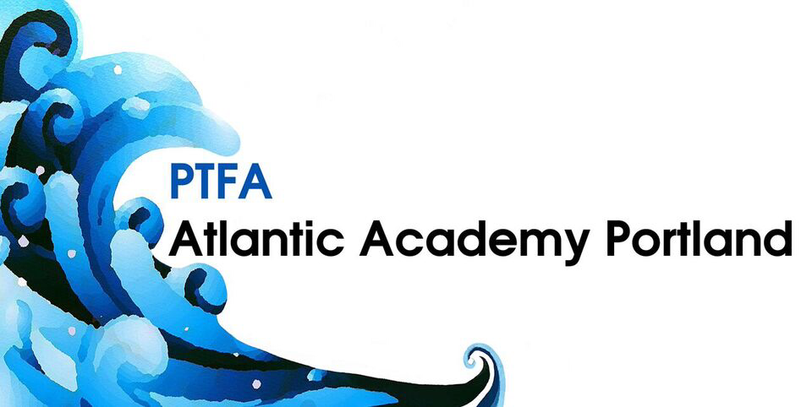

A date for your diaries - the Atlantic Academy Parent, Teachers & Friends association (PTFA) will be holding an Annual General Meeting on Thursday 2nd November 6.45pm - 7.30pm prompt, at Maritime House.
This is open to everybody to attend and indeed, as you are all in effect part of the PTFA, this is an ideal opportunity to find out what we do, how you can be an active member if you wish (no obligation of course but the more volunteers there are the easier it is to put on events), meet outgoing/incoming committee members and a representative from SLT, and enjoy some refreshments.

Hope to see you there
Jess Johnson
Current PTFA Chairperson

